Turkish Journal of Agriculture - Food Science and Technology, 11(s1): 2566-2574, 2023
DOI: https://doi.org/10.24925/turjaf.v11is1.2566-2574.6468

 | Turkish Journal of Agriculture - Food Science and Technology
Available online, ISSN: 2148-127X |  | │www.agrifoodscience.com │ | Turkish Science and Technology Publishing (TURSTEP)

Examination of Kreuzberg Protective Urban Renewal Principles Specific to Tepebağ-Kayalıbağ

Elife Büyüköztürk^{1,a,*}, Murat Oral^{2,b}

¹Department of Architecture, Osmaniye Korkut Ata University, Türkiye
²Department of Interior Architecture, Konya Technical University, Konya, Türkiye
*Corresponding author
ARTICLE INFO | ABSTRACT
Research Article  Received : 12.10.2023  Accepted : 18.12.2023 | Renewing and reuniting the regions of cities that have become collapse areas with the city; urban renewal, which enables the city to be restored, is a term frequently used today. These collapsed areas need to be physically and socially renewed and revitalized. The main purpose of urban renewal studies is to reintegrate the isolated living spaces with the city. This integration should be realized not only physically and economically, but also socially and culturally. Kreuzberg Region in Germany suffered great damage in the World War II and turned into a depression zone over time. The “Protective City Renewal” method, which has been applied in the region since 1961, has an important place in urban renewal studies with its 12 basic principles. Urban renewal works in Tepebağ-Kayalıbağ neighborhoods, which constitute the historical city center in Adana province, are still at the very beginning of the process. Several projects have been carried out within the scope of street rehabilitation studies in the area, but these are thought to be insufficient. The aim of this study is to evaluate the “Protective City Renewal” method and to conduct an experiment on how the 12 principles of this method can be applied to the Tepebağ-Kayalıbağ section, which is an important historical texture to be preserved in Adana.
Keywords:
Urban Renewal
Kreuzberg Region
Adana Tepebağ-Kayalıbağ
Protective city renewal
12 principles

ª |  | ebuyukozturk@osmaniye.edu.tr |  | https://orcid.org/0000-0001-8616-3641 | ^{b} |  | moral@ktun.edu.tr |  | https://orcid.org/0000-0003-4848-5417

This work is licensed under Creative Commons Attribution 4.0 International License

Introduction

The concept of urban renewal, which started with the Industrial Revolution, is to reconsider the physical aging caused by factors such as rapid urbanization, change in urban structure, earthquakes, destruction due to war, and population growth in the urban environment. The concept of urban renewal is an important factor in the change of cities. The concept of urban covers the process of reconsidering and improving the physical, social and ecenomic deterioration in cities (Yiğit, 2011, p.3,4). In otheer words, this concept is the replacement and renewal of places that have become dilapiated as a result of the deterioration of economic conditions in a certain area over time. The main purpose of the renewal process is to make urban enviroments more attractive for financial investments and economic developments, as well as physical conditions (Çiçek, 2014, p.13).
It is an exemplary project for urban renewal studies with its 12 basic principles determined by the “Kreuzberg region project” located near the Berlin Wall, which is successful in the world and in Turkey. The region, which was previously dominated by the destroy-build policy, has achieved to managed the process positively over time. Some studies are carried out within the scope of street rehabilitation projects in Tepebağ-Kayalıbağ Urban Renewal area (Adana historical city center)in Adana province, which is determined as the study area. However, the area has not yet got rid of the ruined appearance and does not include activities that will allow you to spend time in the area.
It is thought that discussing and evaluating these two projects together will be a guide for the study in the Adana Tepebağ-Kayalıbağ region. Based on this, the 12 basic principles created for the Kreuzberg urban renewal project will be tested on the historical city center of Adana, which covers the Tepebağ-Kayalıbağ neighborhoods determined as the study sample area and turns into a collapse area.

Conceptual Framework

In this section, the concept of urban renewal and the emergence and development of the phenomenon of urban renewal are examined.
Concept of Urban Renewal
The concept of urban renewal, which emerged in urban studies as a concept for the regulation of collapsed areas, is a phenomenon that and aims to improve the economic, social and environmental conditions of cities (Erden, 2003).
Urban renewal is a concept that aims to improve the socio-economic, cultural and physical development of the project areas. In a comprehensive sense, it is a study that ensures the participation of the public in urban renewal studies, tries to improve the collapse areas, and aims to advance the economy of the region (Kubat, Özden, 2003).
The main purpose of urban renewal studies is to create healty cities, and in this context, it covers the transformation of illegally built areas, the improvement of areas that have been or will be affected by natural disasters, the transformation of unqualified and unhealty areas within the city into livable areas, and the transformation of historical places and conservation areas that have lost their functions.
Urban renewal examines each region by taking into account the socio-economic conditions within its own physical fabric. Because each region has its own physical and socio-economic structure. Decisions taken for one region will not be appropriate in another region (Erden, 2003).

Emergence and Development of Urban Renewal Phenomenon
The concept of urban renewal is a concept that emerged at the end of the 19th century, at the beginning of the 20th century. The emergence of the concept is parallel to the period of socio-cultural, economic and physical transformations. With the population growth in the cities, renovation works have begun and the population living in the city centers has been replaced by new social layers. As a result of the loss of importance of historical city centers, the housing function available in these areas has been replaced by small commercial units. The area has lost its main user and a social layer brought by new functions has settled in the center. This physical and functional change has negatively affected historical urban centers ( Dıefendorf, 1989)
According to Couch (1997), the concept of urban renewal first emerged in European countries and America. The concept gained importance in the 1950s and gained momentum after the 1970s and 1980s. In 1981, the Council of Europe launched a campaign to renew many European cities. The Bellagio Conference held in 1987 brought reconstruction to the agenda in post-war cities. With the contribution of the “Green Paper” prepared by the European Community Commission in 1990, Western European governments set their own goals for urban renewal. One of these goals is to revitalize the urban region (Özden, 2001, p.259).
In 1994, “Living and Livable City Centers: Struggle Meeting” was held. With the Aalburg Convention signed in the same year, criteria were determined to create sustainable cities. In the “American Society Renewal Law” dated 1997, it was decided to transfer the empty spaces and unqualified buildings owned by the American Department of Housing and Urban Development (HUD) to the local governments authorized in the region (Olson, 1997, as cited in Özden, 2001, p.260).
The concept of urban renewal, which European countries and the United States have been working on for a long time, advocates the protection and survival of urban areas together with their immediate surroundings, while at the same time reclaiming and revitalizing the collapse areas of cities (Özden, 2001, pp. 260-261).
In Türkiye, it developed later than Europen countries and America. Discourses related to this concept emerged in Türkiye in parallel with ecenomic growth in the 1950s, and began to take on the agenda of cities after 1980, but the real development and applications of the concept of urban renewal correspond to the years after 2000. The laws and regulations that emerged in Türkiye in 2004 and after focused on this concept. In the phenomenon of urbanization, new zoning actives were organized and implementation studies were carried out in cooperation with local goverments. In this context, it has been used in the phenomenon of unplanned urbanization, in the rehabilitation of historical city centers, in many dilapidated areas that are considered unhealty, and continues tı be used intensively today (Çağla, İnam, 2009, p.1).

Materials and Methods

The hypothesis of the study; the process of reintegrating urban renewal areas with the city needs to be addressed not only physically and economically, but also socially and culturally. In this context, the 12 basic principles of the Kreuzberg Project, which is a successful example among the Urban Renewal Projects in the World, were examined, and the Tepebağ-Kayalıbağ Urban Renewal area in the province of Adana, which is still at the very beginning of the renewal process. In this context, the method in the study was carried out in three stages. First, the Kreuzberg Urban Renewal area and its basic principles, then the Tepebağ Kayalıbağ Urban Renewal area were examined in detail. In the final stage of the method, 12 basic principles of Kreuzberg Protective City Renewal were tested and evaluated specifically in Tepebağ-Kayalıbağ. In the study, literature data were also examined and on-site detection, observation and photography techniques were used.

Kreuzberg Urban Renewal Project
Kreuzberg District in Germany is a district of Berlin. Kreuzberg region damaged in World War II, over time the city turned into a depression zone (Figure 1). At the end of the 19th century, the Kreuzberg region was used by the working class. In 1960-70, the destroy-build policy continued to exist in the area. In this process, the concept of Urban Renewal meant demolishing the damaged structure, opening large gaps in the area and building new structures. The buildings damaged after the war were abandoned by the main user. Some of the artists, foreigners, the unemployed and some of the lower class of the city continued to use the area. 1980-82 was a period of transition to urban renewal in Kreuzberg. In the studies conducted after these years, priority was given to the protection of existing areas (Tunçer, 2006).

Figure 1. Kreuzberg Region (Tunçer, 2006).

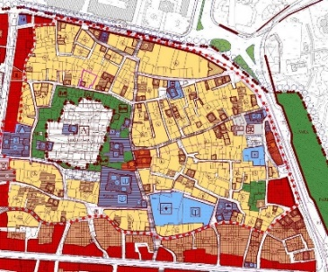
Figure 2. Tepebağ and Kayalıbağ Urban Protected Area (Seyhan Municipality, 2017).

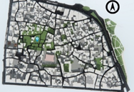
Figure 3. Urban Renewal Area (Büyüköztürk, 2020).

The urban renewal area includes the renovation of 12 buildings on Islands 103 and 104 in the Luisenstadt district of Kreuzberg and the 5036 neighbourhoods of Kreuzberg, which survived World War II without much damage and were envisaged to be rehabilitated in 1983. The contract for the rehabilitation works in the region was signed in 1983 and the works started in 1986. Repairs were completed in 1991 (Yaygel, 2007).
The social structure of Kreuzberg in that time period consists of 25% of the user group newly moved to the area after the destroy-build policy, 25%of the low-income group, and the rest of the foreign Turkish group coming from abroad with immigration (Ünlü, 2009).
Awareness about conservation increased with the International Housing Exhibition (IBA) held in the region. At this stage, 12 basic principles of Urban Renewal have been developed (Tunçer, 2006).

These include:
- Renovation works should be organized according to the needs of the inhabitants of the region and planned together with them.
- Renovation works should be created with harmony between users and application coordinators.
- Damage threatening the essence of the structures must be repaired quickly.
- Renovation works should be able to be carried out progressively over time.
- Public facilities should be renovated and expanded and completed to meet the requirements.
- Renovation work requires agreement on the principles of social planning as a prerequisite.
- In order to guide urban renewal; it is necessary to have a clear form of decision-making, on the other hand, to strengthen the representation of renewal addressees and to establish decision-making rules that hold their meetings in the relevant region.
- Renovation works need definitive financing guarantees.
- It is necessary to use all chances to develop new forms of contracting organizations.
- All measures should ensure that the renovation works are carried out over time after 1984 (Ünlü, 2009).
Kreuzberg Urban renewal project has been prepared in line with the needs of the field user. Thus, people living in the region were included in the project process (Yaygel, 2007). Public areas found inadequate in the project have been increased. It is aimed to create new social spaces such as schools, kindergartens, youth centers, elderly clubs, district women’s centers, neighborhood centers. In addition to social areas, plans have been made to find jobs for the unemployed. (Ünlü, 2009).
The Kreuzberg Renovation project is a study carried out with wide participation. It was carried out with the support of the Berlin Municipality and IBA organizations. In addition, tenants, business owners, owners, architects and urban planners, artists, redevelopment contractors, Berlin public institutions, politicians, mass media officials participated in the project (Ünlü, 2009).
The project has an important place in urban renewal works with its 12 basic principles. Especially the inclusion of the user’s in the project and making plans in line with the user needs are the most important reasons for the success of the project.

Tepebağ-Kayalıbağ Urban Renewal Works
Tepebağ-Kayalıbağ Urban Renewal Area constitutes the whole of the urban protected area of Adana province. The study area constitutes the historical texture, which is the first settlement of the city (Figure 2).
After the proclamation of the Republic, there was an increase in the need for housing with the improvement of the economy of the city of Adana and the increase in immigration to Adana. Changes have been made in the traditional houses in the area that constitutes the historical city center of Adana in line with the needs. Partitions were added to the buildings, floors were built on top of them, and unqualified structures were started to be built in the historical area and the texture was damaged. Thus, the historical texture was damaged (Umar, 2010).
The historical city center, which is preferred by people with high income levels, has turned into a region where people from rural areas settle over time. New users who settled in the region could not take care of the area due to financial impossibilities, which caused the houses to wear out (Seyhan Municipality, 2023).
Adana Conservation Zoning Plan was prepared between 1996-1998. The conservation zoning plan prepared for Tepebağ Mound and its surroundings could not be implemented due to the 1998 Adana earthquake (Reel, 2006). In the examinations carried out in the area after the earthquake, it was determined that there was damage and destruction in 241 registered buildings (Gürçınar, 2000). Improvement works in the area after the earthquake have not been carried out for a long time. A new Conservation Zoning Plan was adopted in 2016. In this plan, partial improvements have been proposed in the area within the borders of Seyhan Municipality, which is determined as OPA. There are a total of 597 buildings in the study area. 63 of these structures are registered and 6 of them are monumental buildings (Büyüköztürk, 2020) (Figure 3).
Studies Conducted to Date in Adana Tepebağ-Kayalıbağ Region
In the Urban Renewal Area within the borders of Tepebağ-Kayalıbağ neighborhood of Adana province, restoration projects and street rehabilitation projects were carried out on the basis of individual buildings until 2023.

Restoration Works in the Area
Single projects restored within the boundaries of Tepebağ-Kayalıbağ neighborhoods; Atatürk House project, Gazipaşa Primary School Project, Şeyhoğlu Mosque Project, Green Masjid and Tomb Project, Şefika Hatun Mosque Project, Tepebağ Secondary School, Inventory Project No. 63, Inventory Project No. 64, Adana Cultural Heritage Preservation Regional Board project, Adana Cinema Museum project, Bosnian Hotel project, Inventory Project No. 109, Salvation School (Kadem Building) project, Inventory Project No. 175 (Turkish Pharmacists Association) project, Tepebağ Kuran Course Project (Figure 4-17).

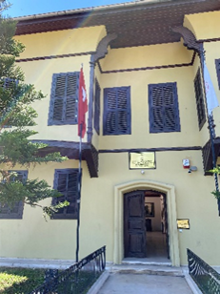 | 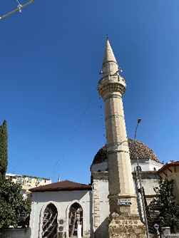 |  | 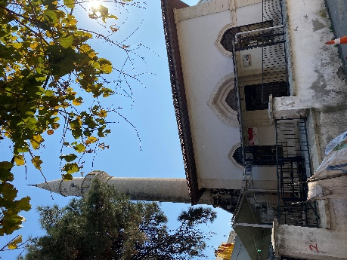 |  | 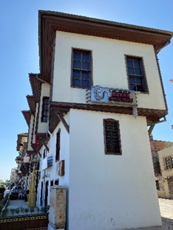
Figure 4. Atatürk House  (2023) | Figure 5. Şeyhoğlu Mosque (2023) |  | Figure 6. Şefika Hatun Mosque (2023) |  | Figure 7. Cinema Museum (2023)
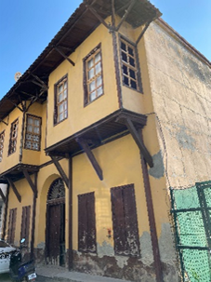 | 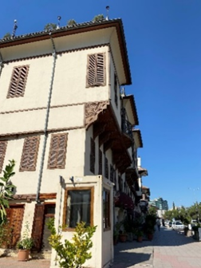 |  | 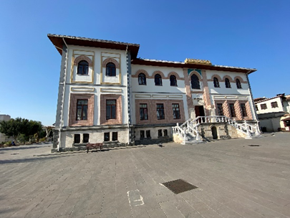 |  | 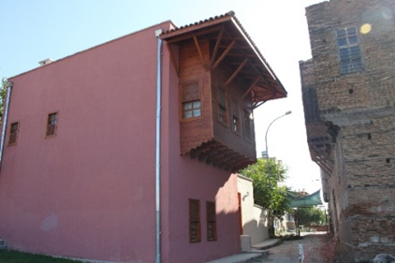
Figure 8. Inventory No. 99 (2023) | Figure 9. Bosnian Hotel  (2023) |  | Figure 10. Gazi Pasha Primary School (2023) |  | Figure 11. Inventory Projects No. 63-64
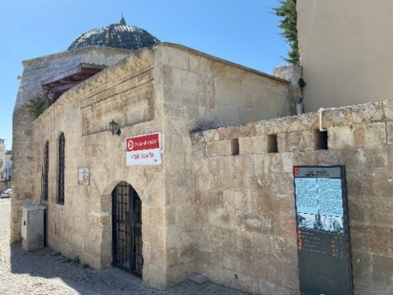 |  | 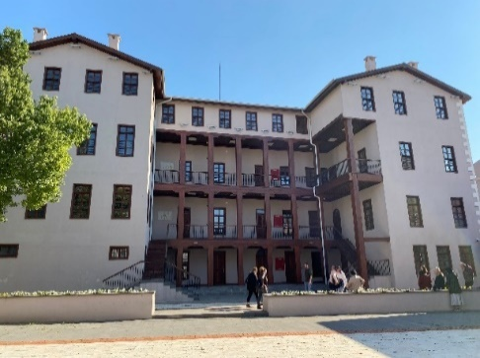 |  | 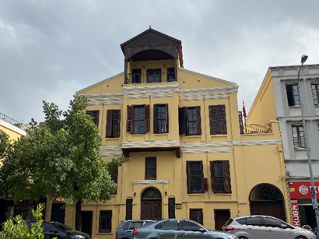
Figure 12. Green Masjid  (2023) |  | Figure 13. Tepebağ Secondary School (2023). |  | Figure 14. Adana Regional Board for the Protection of Cultural Heritage (2023)
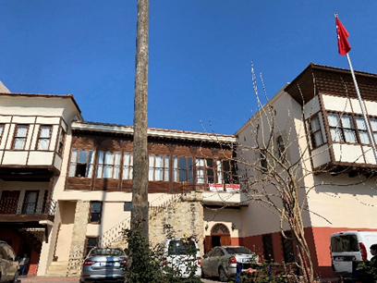 |  | 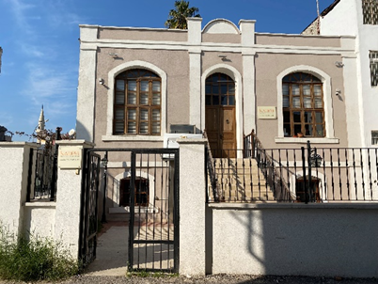 |  | 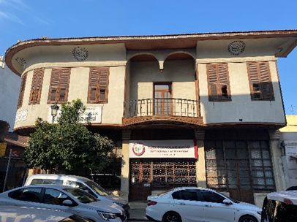
Figure 15. Tepebağ Kuran Course  (2023) |  | Figure 16. Liberation School ( Kadem Building) (2023) |  | Figure 17. Inventory No. 175 (Turkish Pharmacists Association) (2023)

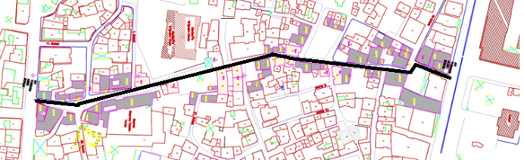 | 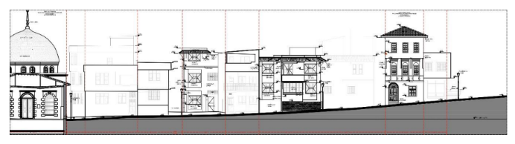
Figure 18. Atty. Turhan Arın Street  (Seyhan Municipality, 2019). | Figure 19. 26012 Street Silhouette  (Büyüköztürk, 2023).
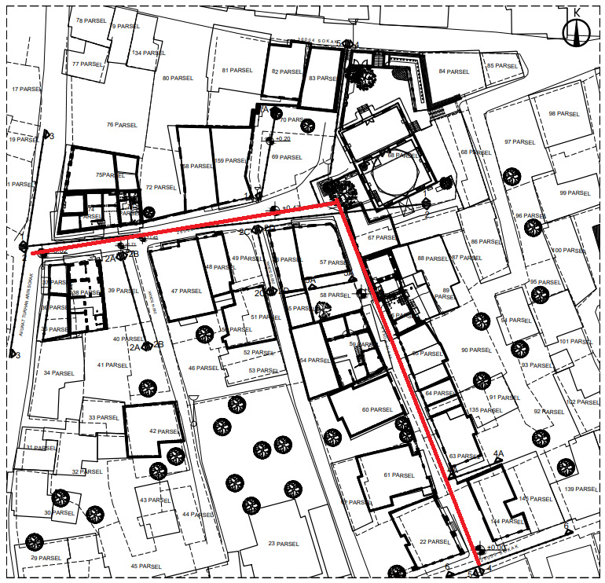 | 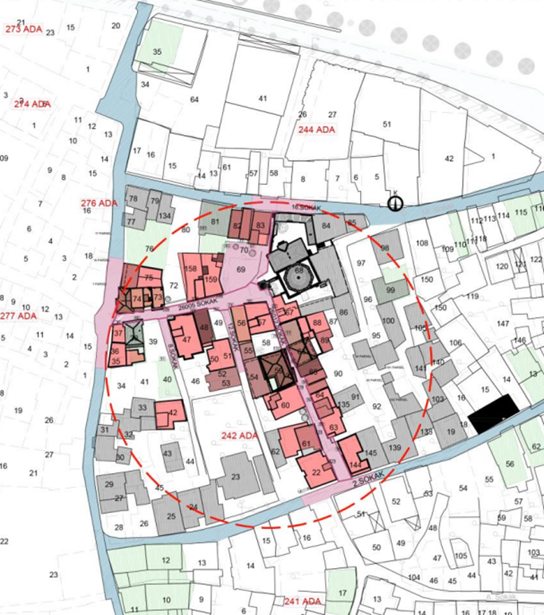
Figure 19. 26005 and 2012 Street Rehabilitation Project (Seyhan Municipality, 2023). | Figure 20. 26005 and 26012 Street Rehabilitation Project (Büyüköztürk, 2023).

Atty. Turhan Arın Street Rehabilitation Project
Tepebağ is a region between Kayalıbağ neighborhoods. There are Green Masjid, Tepebağ Kuran Course, school, dormitory building, registered buildings and today’s buildings in the area (Büyüköztürk, 2020) (Figure 18).
Within the scope of Av.Turhan Arın Street Rehabilitation Project; infrastructure works, facade and roof renovation of buildings, lighting and renovation of urban furniture (benches) have been carried out (Seyhan Municipality, 2019).

26005 and 26012 Street Rehabilitation Project
Within the scope of the street rehabilitation project numbered 2012, the restoration projects of the building named Inventory No. 95 in the Conservation Zoning Plan have been completed and the restoration of the building called café library and inventory No. 103 is ongoing and it is planned to be used as a playhouse (Seyhan Municipality, 2023) (Figure 19-23). Within the scope of the street rehabilitation project No. 2005, the restoration of the ground floors of Inventory No. 92 and Inventory No. 93 was carried out (Figure 3.24).

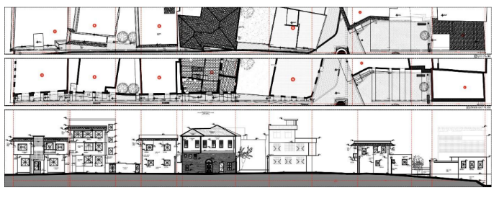
Figure 21. 26005 and 26012 Eastern Front Street Silhouette (Büyüköztürk, 2023).

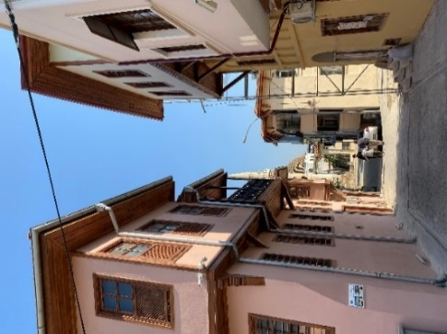 | 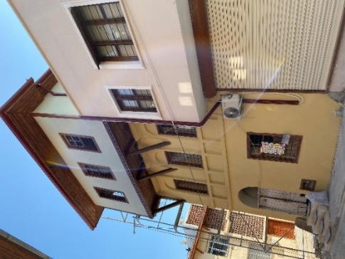 | 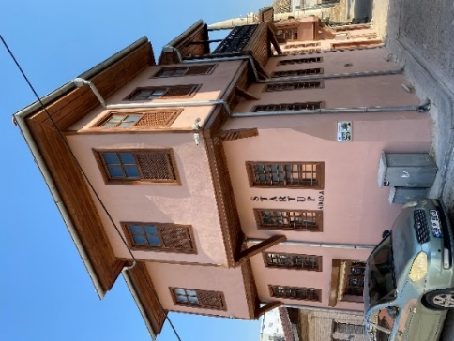 | 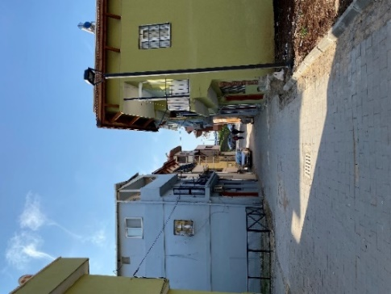
Figure 23. 26012 Post-Street Rehabilitation (2023)
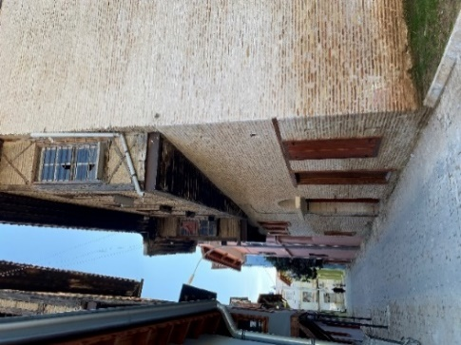 |  | 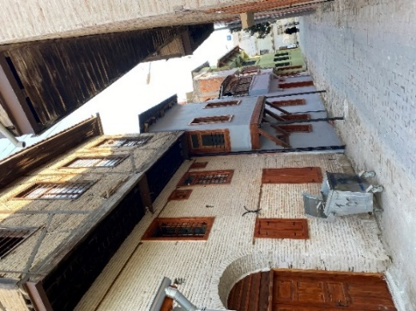
Figure 24. 26005 Post-Street Rehabilitation (2023)

Evaluation Of Kreuzberg Protective City Renewal Principles On Adana Tepebağ-Kayalıbağ Urban Renewal Area
In this study, an evaluation is made on how the “Protective City Renewal” principles applied in the transformation in the “Kreuzberg” neighborhood in Berlin and found successful all over the world will be handled in the historical city center within the borders of Tepebağ-Kayalıbağ neighborhoods in Adana province.
Principle 1. Renovation should be planned together with the local people, taking into account the needs of the local people.
Ensuring public participation in the projects increases the success level of the project. Since the deficiencies in the area are determined correctly in the projects designed with the user and the wishes of the local people are taken into consideration, urban renewal works are longer-lasting.
Problem: Tepebağ-Kayalıbağ region lost its main user due to the shift of the city to the north and the 1998 earthquake. Over time, the region has turned into an area preferred by narrow families, especially by those who migrated from the eastern provinces to Adana to work.
Experience: New users welcome any improvement to the region, which has become a depression zone due to financial impossibilities.
Evaluation: In the studies carried out in the Adana-Tepebağ Kayalıbağ Urban Renewal Area, interventions were made by obtaining a letter of appreciation from the users during the project and repair phase. In the studies, expropriation studies were carried out because the area lost its first user (Seyhan Municipality, 2023).
Problem: Decisions about the area are taken by the administrative administration (Adana Metropolitan Municipality, Seyhan Municipality and Seyhan Municipality KUDEB unit). Public participation could not be ensured in the studies in the field.
Principle 2. Urban Renewal should emerge with the harmony between users and project implementers.
In the works carried out, city councils should be established and areas should be created to allow the public to make decisions together.
Problem 2. In the studies, city councils were not established to fully cover the subject. They stated that they were open to all kinds of work carried out in face-to-face interviews with the people of the region, but there were deficiencies at some points.
Experience 2. The security problem continues in the region, but solutions are insufficient in this regard (The lighting elements have been replaced.) Another problem is that the vacant lands are used as parking lots. The location of the houses destroyed in the earthquake is still used as a parking lot. These parking lots are unlicensed. Since the area is in the middle of 4 heavily used commercial axles, the need for parking is very high. However, this should be resolved by the project executives where it is licensed and deemed appropriate. Parking and security problems in the region are the topics that area users are uncomfortable with from the beginning of the process. In the face-to-face interviews with the users, it was learned that they had difficulty in using the area at night. If the public had been included in the studies from the beginning of the urban renewal process, these headings would not have been ignored, and the security and parking problem could have been handled more meticulously (Figure 25-26).

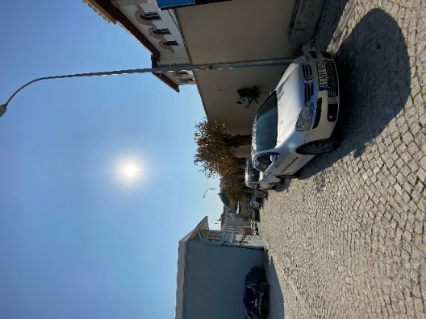 | 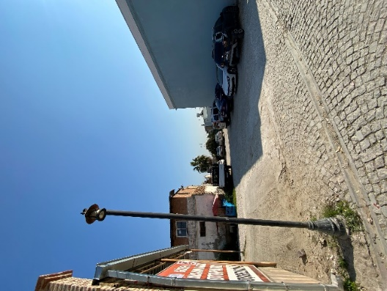 | 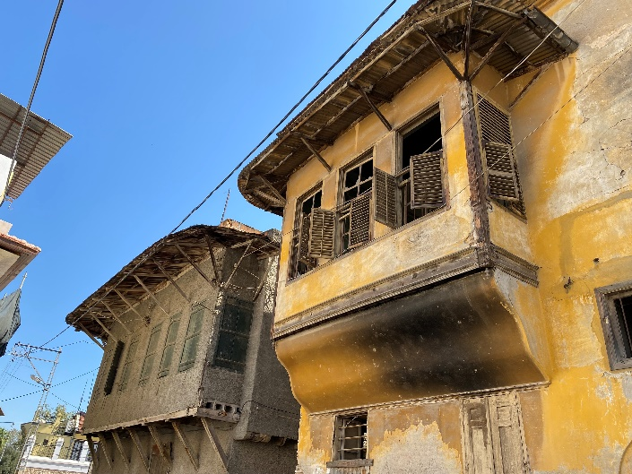
Figure 25. Parking problem in the area (2023) | Figure 26. Parking problem in the area (2023) | Figure 27. Tepebağ-Kayalıbağ Region

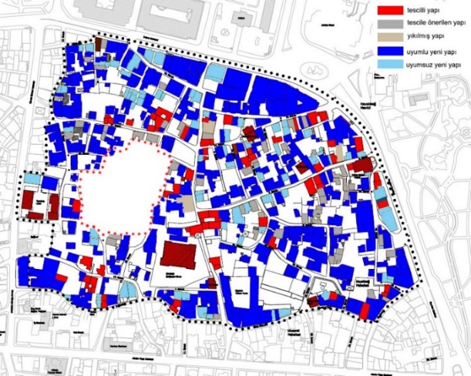 | 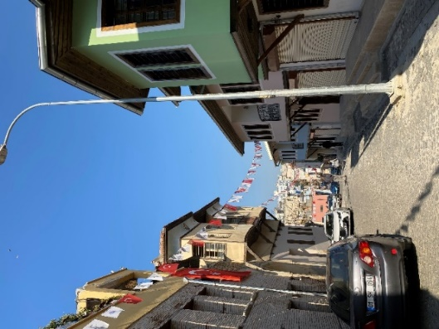 | 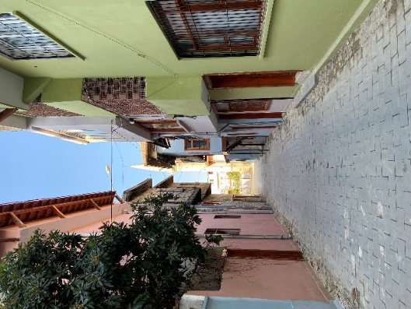
Figure 28. General Characteristics of Tepebağ-Kayalıbağ Region (Büyüköztürk, 2020). | Figure 29. Atty. Turhan Arın Street (2023) | Figure 30.26005 Street(2023)

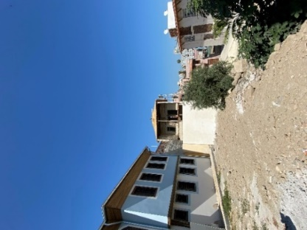 | 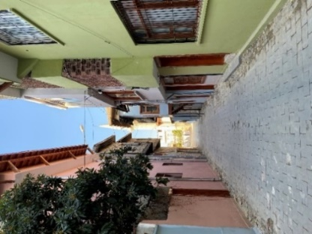 | 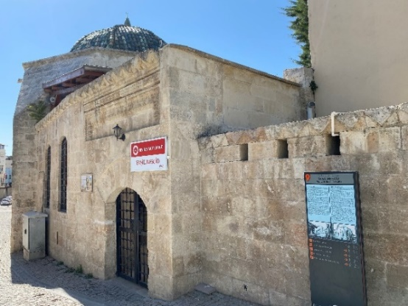 | 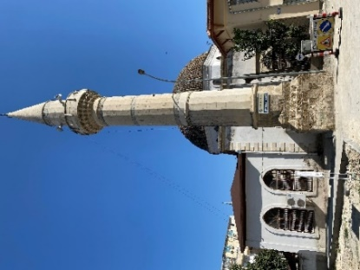
Figure 31. Atty. Turhan Arın Street (2023) | Figure 32. 26005 Street(2023) | Figure 33. Yeşil Masjid  (2023) | Figure 34. Şeyhoğlu Mosque (2023)

Evaluation 2. Users have a positive view of the work done. Because the area is very neglected and idle. However, there are still deficiencies in the region. These deficiencies should be resolved by user satisfaction analysis. Positive results can only be achieved with the cooperation of users and project managers.
Principle 3. Damages that occur on historic buildings must be repaired quickly.
Problem 3. Tepebağ-Kayalıbağ urban renewal works were delayed. Since the damages in the buildings were not repaired quickly, the area turned into a collapse zone. The lack of applications for repairing damages in the area other than street rehabilitation projects still poses a major problem (Figure 27.).
Experience 3. Little investment was made in the area after the earthquake, but these were limited to a few private entrepreneurs. Financial impossibilities have delayed the recovery in the field.
Evaluation 3. The region should have been intervened quickly after the 1998 earthquake, but decisions about the region were taken in 2016 (in the Conservation Zoning Plan) (Figure 28).
Facade and roof repairs, sewerage, infrastructure, lighting elements and flooring were renovated within the scope of street rehabilitation projects in the area (Figure 29-30).
Principle 4.5.6. Projects should be progressively realizable. In the studies conducted, the destruction should be kept to a minimum. Studies in which green areas are increased and walls are improved should be envisaged.
Problem 4.5.6. There is very little green space in the area (Figure 31-32).
Experience 4.5.6. During the work carried out in the new regions, additions are made to the previous period’s work. However, this situation is insufficient.
Evaluation 4.5.6. The studies carried out in the region are carried out gradually. First, Atty. Turhan Arın Street Rehabilitation Project (1st Stage and 2nd Stage), then implementation projects of 26005 and 26012 Street Rehabilitation Projects were carried out. Afterwards, individual project repairs were made and rehabilitation works were continued. During each stage project, the deficiencies of the previous stage are also intervened.
Principle 7. Public structures and spaces should be renewed in line with the needs.
Problem 7. Renovation of public buildings takes a very long time. This is especially the case in projects carried out by the General Directorate of Foundations. Another problem is that public spaces are not created. Areas such as playgrounds, parks, etc. have been given very little space in the project and there is no such application in the area yet.
Evaluation 7. Within the scope of renovation and rehabilitation projects in the area; Gazipaşa Primary School, Yeşil Masjid, Şefika Hatun Mosque, Bekir Sapmaz Girls’ Dormitory, Şeyhoğlu Mosque, Tepebağ Secondary School, Tepebağ Kuran Course structures have been improved and repaired.
Principle 8. Urban Renewal projects primarily require agreement on the project work.
Problem 8. At the social and economic level, the decisions taken about the area at the project stage aimed to transform this place into a tourism region. However, the studies conducted are insufficient in this regard. The functions given to the buildings during the project phase have not yet been implemented.
Experience 8. There is no study that will allow the visitors coming to the area to stay here for a long time.
Evaluation 8. In order to determine the Social Planning Principles in the example of Tepebağ-Kayalıbağ, it is necessary to determine the social, economic, cultural and conservation levels of the building owners.
Principle 9. In order to increase the level of success in the implementation of urban renewal, decisions should be taken clearly and decision-making boards should be established.
Problem 9. Decisions were taken by the authorities. The people of the region did not participate in these decisions.
Evaluation 9. In the studies carried out in Tepebağ-Kayalıbağ region, the decisions were taken by Adana Metropolitan Municipality, Adana Seyhan Municipality, Seyhan Municipality KUDEB, Adana Governorship, General Directorate of Foundations.
Principle 10. Financing guarantee is very important in renovation works.
Problem 10. The main reason for the inability to work for a long time in the region is the inability to provide financing guarantees.
Evaluation 10. The financing guarantee for the region was provided by Çukurova Development Agency, Adana Governorship YIKOB (It has given a certain rate of real estate tax as guarantee.), Cultural Heritage Protection Board (Contribution).
Principle 11. We should take our chances to the full to develop new forms of contracting organizations.
Problem 11. In the studies carried out in the field, contracting organizations are limited to public companies.
Evaluation 11. Renovation and expropriation works carried out in the region are widely used.
Principle 12. Decisions taken in the field should also be open to studies to be carried out over time.
Evaluation 12. The gradual realization of projects in the Tepebağ-Kayalıbağ area and the ability to intervene in the previous stage are important in terms of ensuring sustainability. However, it is necessary to ensure the continuity of this situation.
When the Adana Tepebağ-Kayalıbağ region is examined within the​ ​principles; it has been determined that the user of the area has not been included in the project and implementation process, all the damages have not yet been eliminated, functions that will contribute economically to the area have not been proposed, problems such as parking, green space and security have not been solved in the area, and indoor and outdoor areas have not been created to spend time in the area (food and beverage unit, park, cafeteria, buffet, children’s playground, etc.).
The main factor in the success of the project implemented in the Kreuzberg region is the inclusion of the field user in the project and application. In the projects designed together with the user; the main needs and requests in the region are determined. Thus, studies with increased permanence emerge. Another factor in the success of the projects in the Kreuzberg region is the rapid repair of the damages in the region. Removal of the ruined image in the area with an urgent program positively affects both the people of the region and the visitors to the area. Units that offer new jobs in the field and studies that aim to find jobs for the unemployed are another success criterion of the project. The urban renewal area of the Kreuzberg region is a multi-actor study in which high financial support is also provided.
In Tepebağ-Kayalıbağ region; a disciplined study should be carried out by considering the 12 basic principles adopted in the Kreuzberg Urban Renewal area in full. In addition to public participation in decisions related to the field, the number of actors involved in the process should be increased and financing support should be provided.

Results and Discussion

It was emphasized in the study that urban renewal projects have become a great need for our cities. Especially historical city centers have been exposed to aging over time and turned into depression areas. The Kreuzberg region, which was damaged after World War II, was previously a depressed area of the working class, and it correctly managed urban renewal projects with the studies carried out over time. The Kreuzberg urban renewal project envisages the development of projects that take into account the needs of the people of the region with the decisions taken, enable economic recovery, ensure public-private cooperation in studies, enable sustainability that can be carried out gradually, and ensure the rapid elimination of damages in buildings. Adana Tepebağ-Kayalıbağ region is at the very beginning of the urban renewal process. Studies by local governments to save the area from the collapse area are insufficient and need to be handled systematically, such as the Kreuzberg project.
In this study, the principles of the Kreuzberg Urban Renewal project were examined in the Tepebağ-Kayalıbağ area in Adana province. When these 12 principles are examined in the area, it is observed that the users living in the historical city center of Adana province are not included in the process, the problems experienced in the area have not yet been solved (security, green area problem), the functions that will provide economic input to the region are not recommended, and the damages are eliminated in certain parts of the region.
Addressing these two projects together will be a guide for the Adana Tepebağ-Kayalıbağ project. The study applied in Kreuzberg region is a guide to get positive results from the studies in Tepebağ-Kayalıbağ region.

Conflict of interest

The authors devlare that they do not have any conflict of interest.

Acknowledgements

This research was presented at the 3rd International Congress of the Turkish Journal of Agriculture - Food Science and Technology, Malatya, Turkiye, held on 13 and 16 September 2023 (as an oral presentation).

References

Büyüköztürk E. 2020. A Model Proposal for Sustainable Conservation-Development in Urban Protected Areas: Adana Tepebağ-Kayalıbağ Mevkii. PhD Thesis. Konya Technical University, Institute of Science, Konya, Türkiye.
Büyüköztürk E. 2023. Evaluation of Conservation Problems in Historical Urban Tissues within the Scope of Street Health Studies, 1. Bilsel International Ephesus Scientific Research and Innovation Congress, İzmir, p. 220-221.
Couch C. May 1997. A Comperative Study of Plans and Policies for Town Centre Renewal in France and UK, Vol.12.
Çağla H, İnam Ş. 2009. A Review on Urban Renewal Project Implementations Led by Local Governments, TMMOB Chamber of Surveying and Cadastral Enginers 12th Turkish Mapping Scientific and Technical Congress, Ankara.
Çiçek İ. 2014. Evaluation of Urban Renewal Areas with the Sustainable Development Model, Windmill Example, Istanbul Technical University, Instute of Scince and Technology, Master’s Thesis, Istanbul.
Diefendorf J. 1989. Urban Reconstruction in Europe After World War II, vol. 26, p.128.
Erden YD. 2003. Transformation Projects as a Tool in Urban Innovation, MSU Institute of Natural Sciences City-Regional Planning US Urbanism PhD Thesis, Istanbul, Türkiye.
Kubat AS, Özden PP. 2003, Reflections on the Applicability of Urban Renewal in Türkiye. ITU Journal of Architecture, Planning, Design, 2(1).
Olson CL. 1997. The American Community Renewal Act, The Heritage Foundation Issue Bulletin, No. 229.
Özden PP. 2001. Reflections on the Role of Local Governments in Urban Renewal Practices and the Case of Istanbul. I.Ü. Journal of the Faculty of Political Sciences, No: 23-24: 255-270.
Seyhan Municipality. 2023, Adana Seyhan Municipality KUDEB.
Tunçer M. 2006. 12 Principles of Protective City Renewal from Kreuzberg to Fener-Balat. 42. Isocarp Congress, Istanbul.
Ünlü A. 2009, City and People, 28. International Building and People Congress. http://webdeyim.net/tr/e_dergi/mimarlar-odasi-bursasubesi/21-uluslararasi-yapi-ve-yasam-kongresi.
Yaygel AD. 2007. User-Oriented Healthcare Methods for Historical Urban Environments Requiring Intervention: The Case of Izmir-Basmahane Region, Dokuz Eylül University Institute of Science and Technology Master Thesis, Izmir, Türkiye.
Yiğit G. 2011. Urban Renewal and Istanbul: Tarlabaşı Example, Marmara University, Instute of Social Sciences, Department of Public Administration, Master’s Thesis, Istanbul.

